in conjunction with http://www.dollhousestylingstudio.com * 254-744-1656
and Nifty Treasures
https://www.facebook.com/profile.php?id=100002887891835
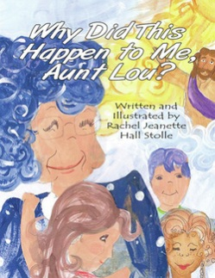
Presents: Paint Waco Blue
April 20th at The Dollhouse at 123 Tokepa in Hewitt, Texas
April 27 at Erath Building on Tree Lake Rd in China Spring
To help spread awareness of the silent epidemic of child abuse during April, Child Abuse Awareness Month
% of sales of salon products go towards purchasing “Why Did This Happen to Me, Aunt Lou?”, a book for childhood abuse victims, for the Waco Family Abuse Center
Presale Products Available:
Blue hair extensions: $10
Blue ‘Dollface’ designer eye shadow: $15
Embroidered I Am An Abuse Survivior Tee: $20 DESIGN 1 on order form
Embroidered I know an Abuse Survivor Tee: $20DESIGN 2 on order form
Embroidered Paint Waco Blue Tee: $20 DESIGN 3 on order form
For more information and details on other sponsors visit http://auntloubooks.weebly.com/paint-waco-blue.html
or contact Rachel Stolle at streamsmoms@yahoo.com

